**COVER PAGE**

**Ahmed Tarek Fahmy Mohammaden**

**B. N.: 71**

**Date: June 4, 2020**

**Topic: Artificial Intelligence**

**Github link:**

**Github-page (published website):**

**Application Brief:**

*Artificial intelligence (AI) is a collective term for computer systems that can sense their environment, think, learn, and take action in response to what they’re sensing and their objectives. The most attractive issues in this field are; its high growing rate, its amazing impact on most life sectors; the unbelievable futurity, the continuous racing between the different countries to jump up the top of this technology as well as the optimistic forecasting of global economy by the effect of AI.*

Finally, I think the following statement expresses well about relation between man and AI: “most the things we enjoy in our life are mostly be results of AI, so more utilization and enforcing of human intelligence with the AI has big potential for better future”.

**Screen Shots:**

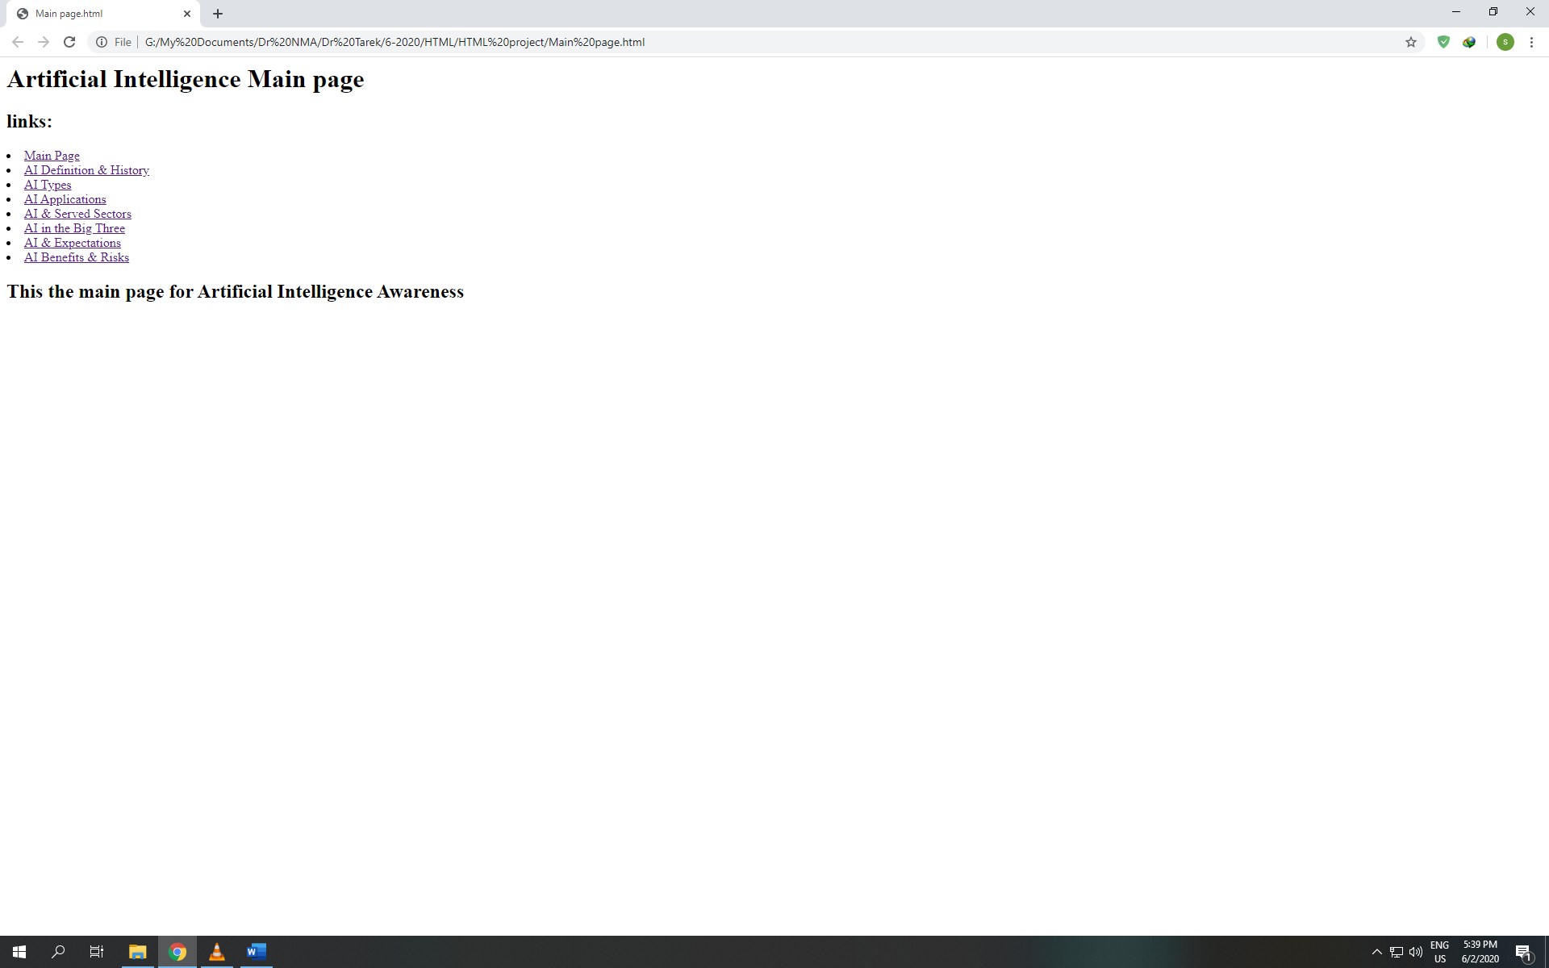

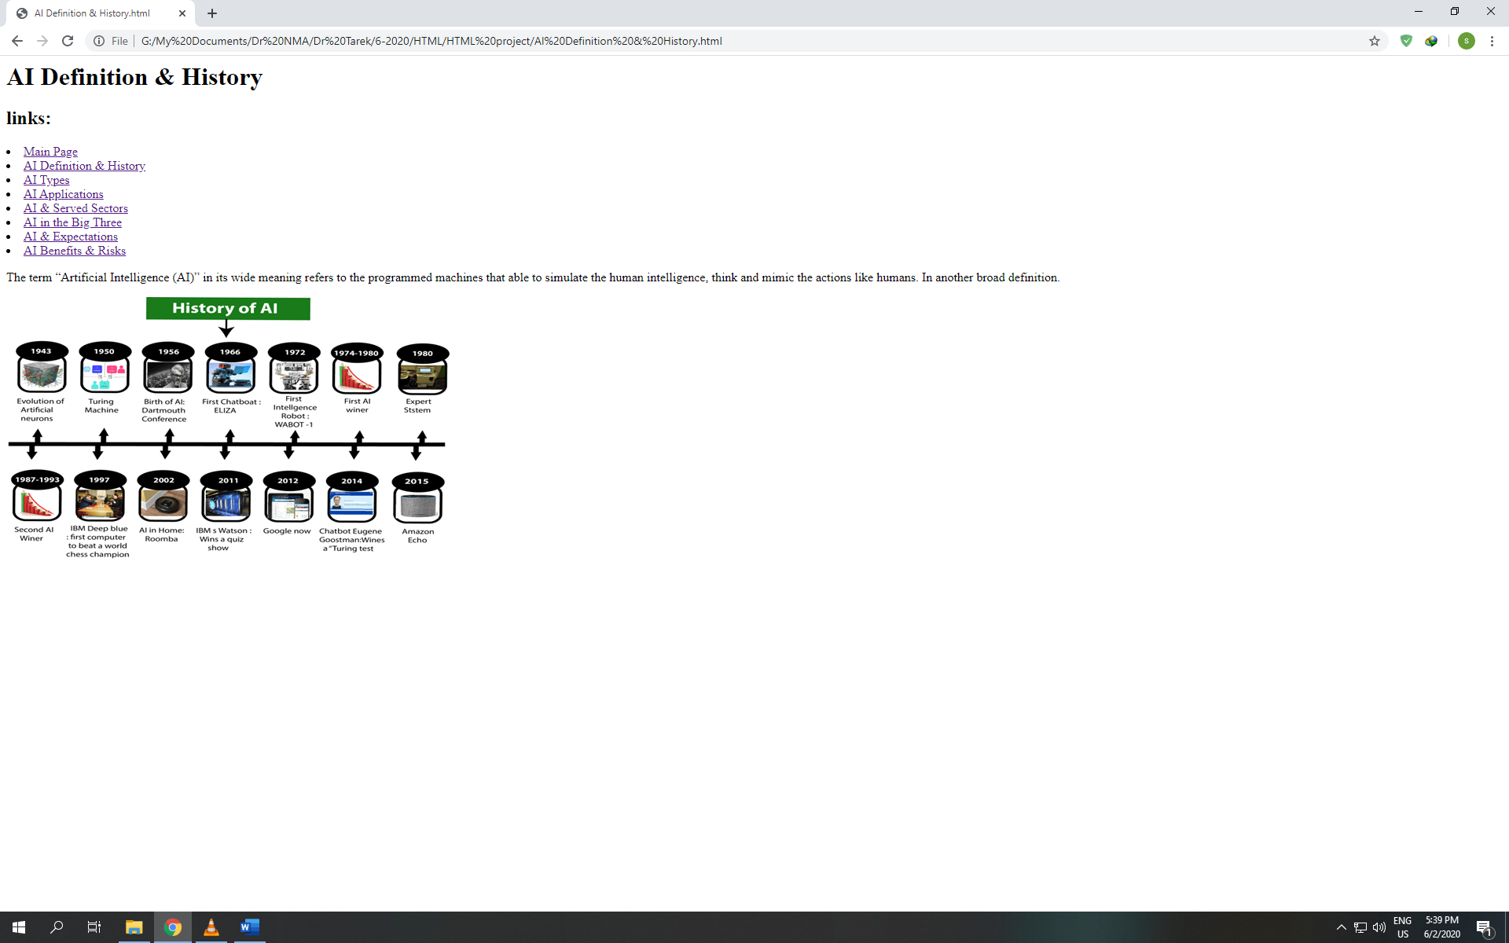



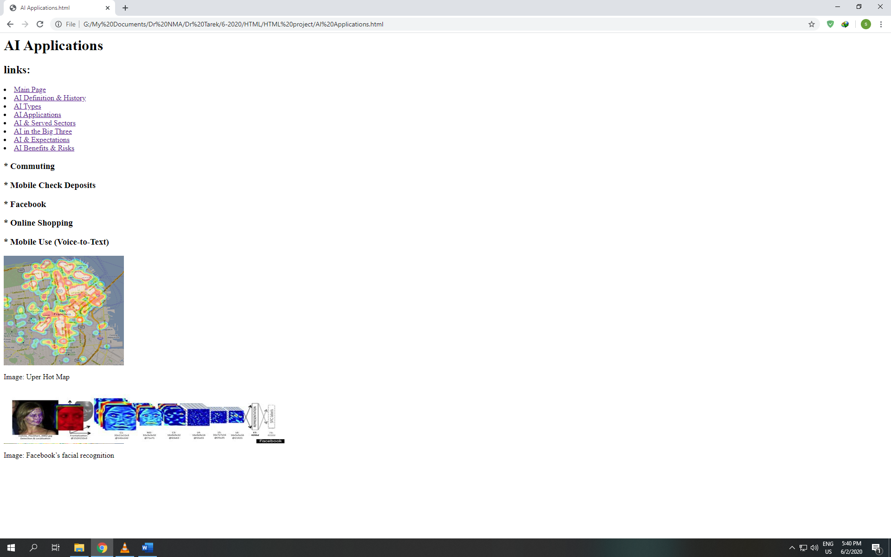

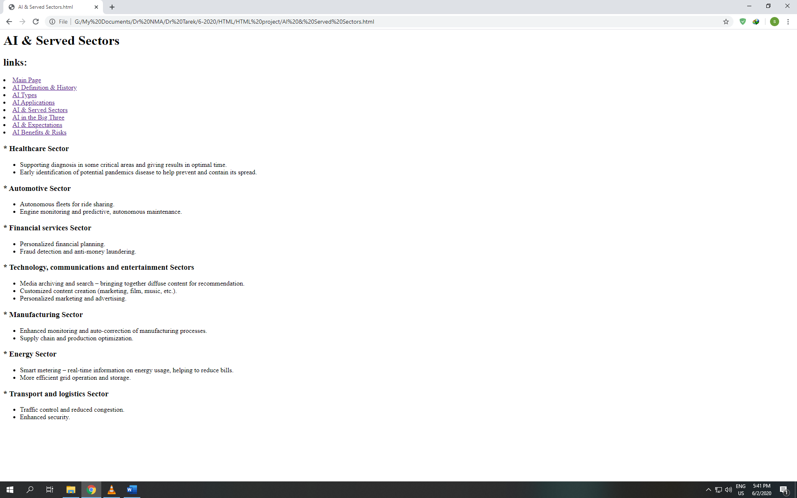

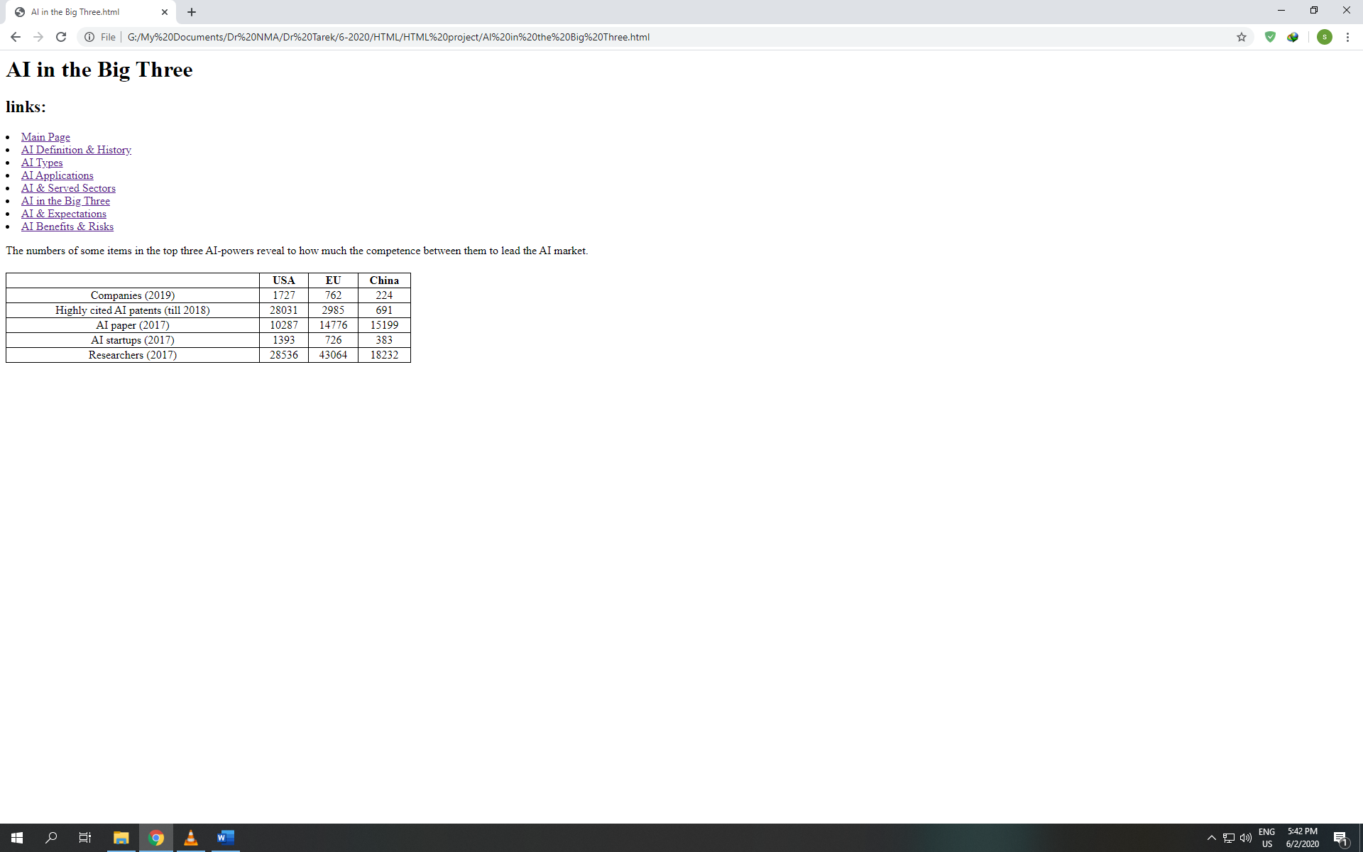

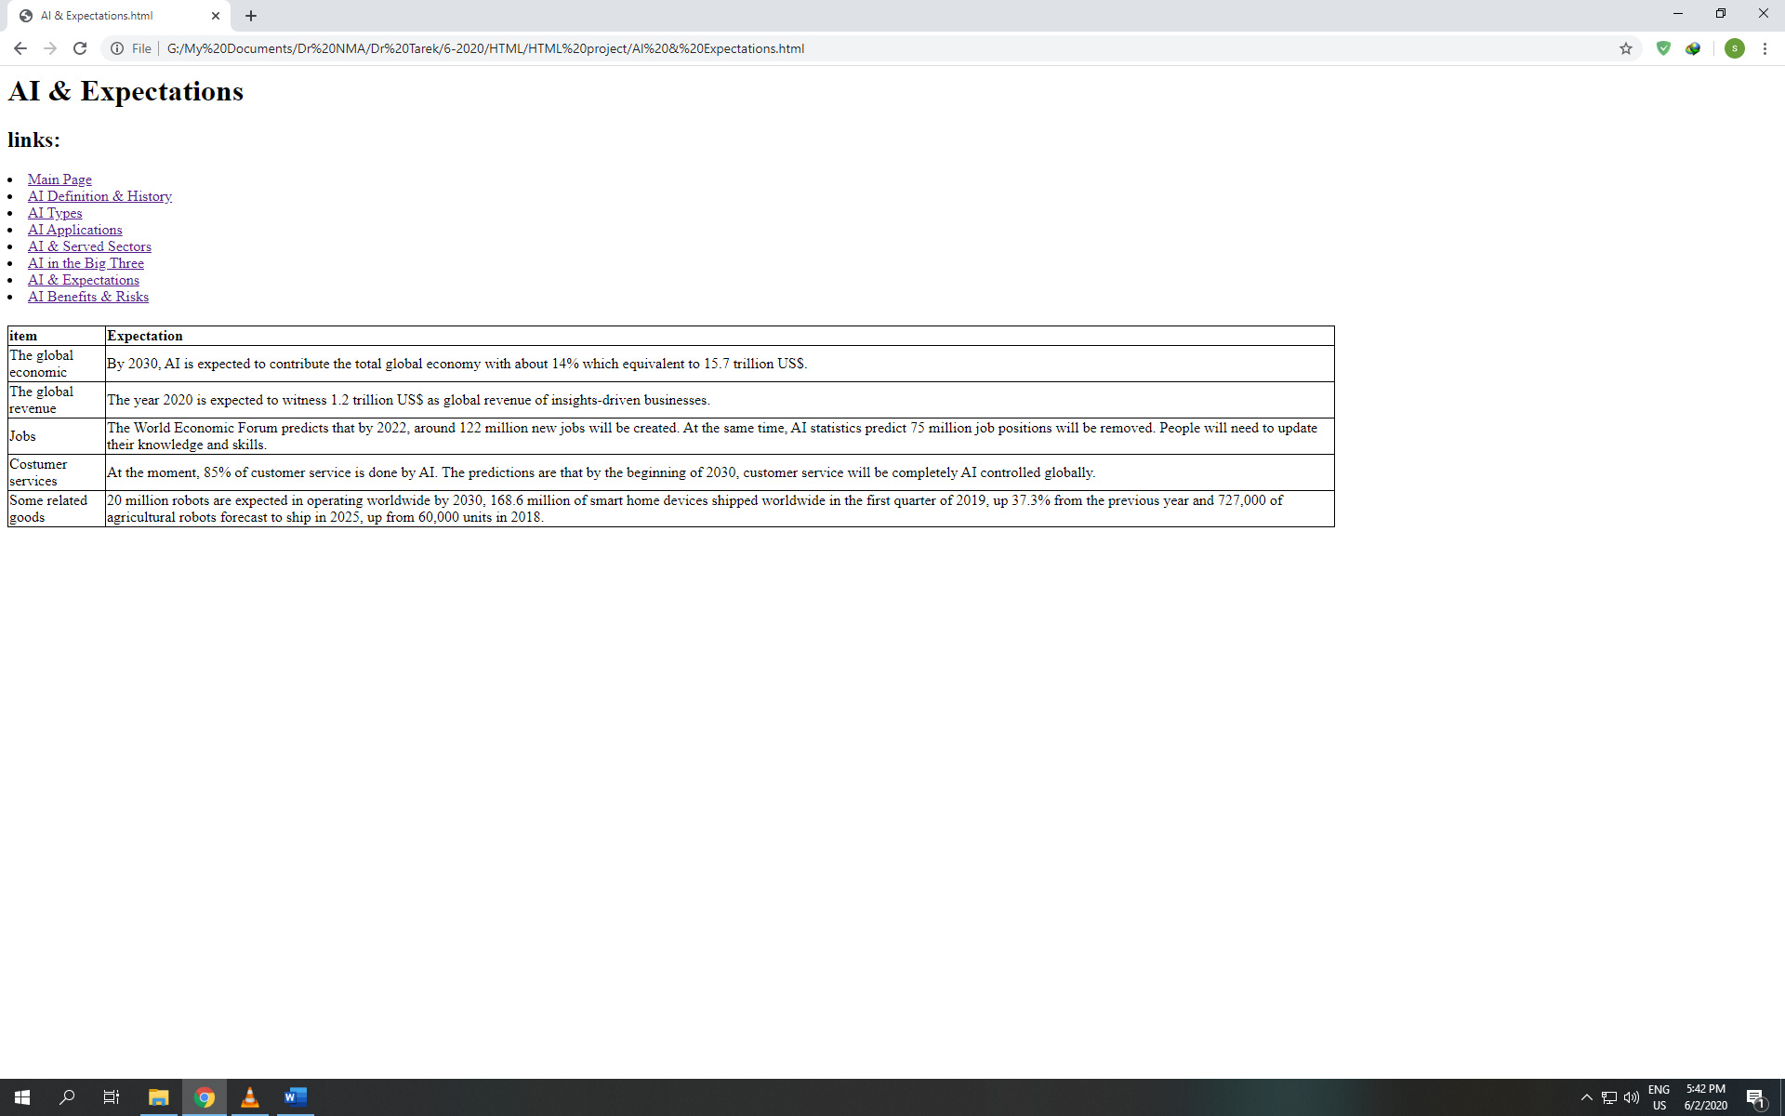

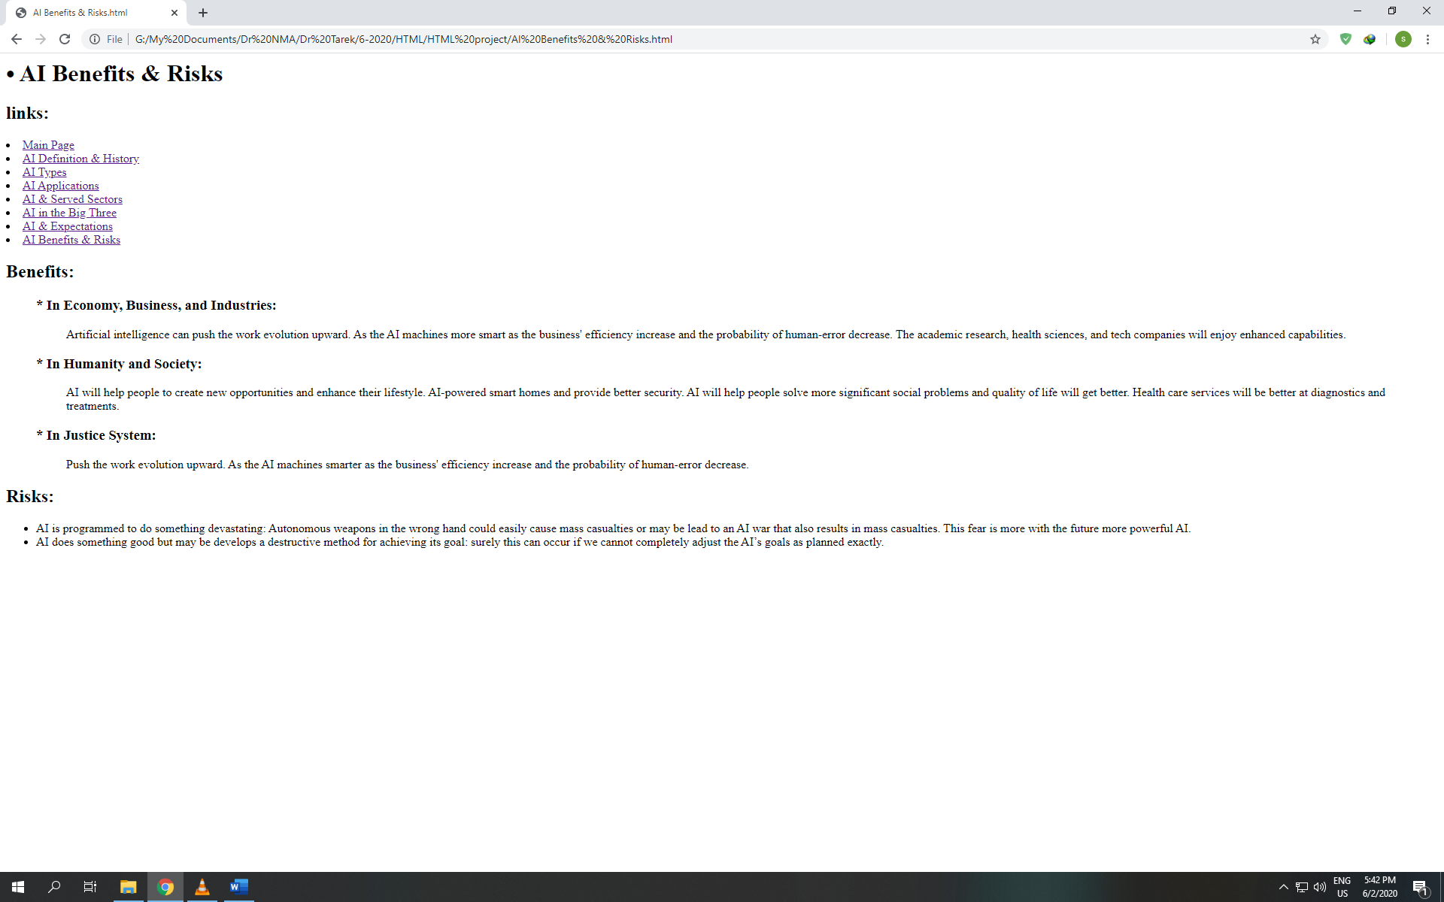

**Source code:**



